**Week 7 Lab Assembler**

**Group 65**

**Integrants: 110504517 李睿穎 (Leader)，110504518 鍾秉均 (Member)**

**Full Code**

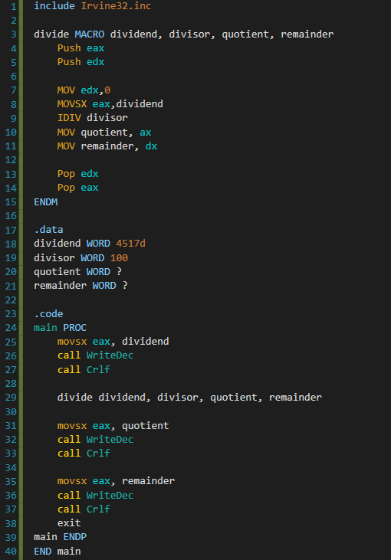

**Explanation**

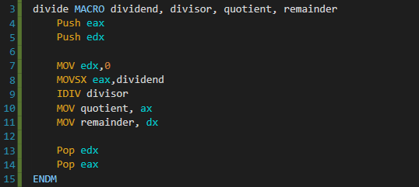

The logic we used for this week’s lab was pretty simple and straightforward, what we do here first is create a macro function where the parameters are the components of a simple division.

Here the IDIV function works with eax register, as you can see eax works as the dividend and when we call the IDIV function we need to pass the divisor, what it does next is just divide eax with what we have just passed to it. The quotient then is stored in ax and the remainder is stored in dx, what we do is just moving those results to the corresponding variables and the work is pretty much done.

**Register Change**

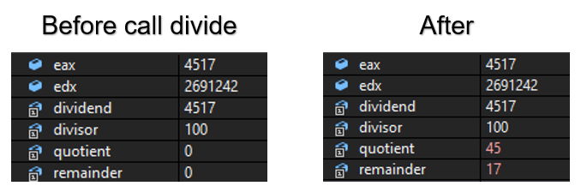

**Print Result**

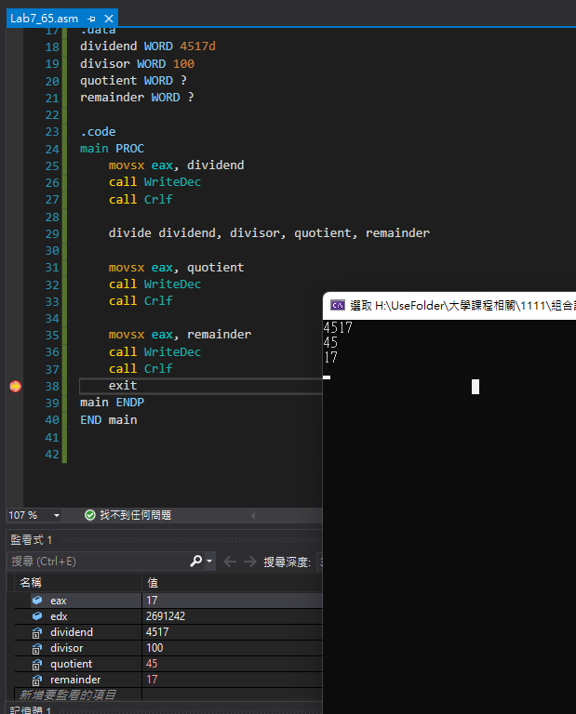

**Reflection**

For this week’s lab we learned how to create a MACRO function and how to use the DIV command in assembler. Although it may sound simple, but we thank the TA’s for giving us the opportunity to try out what we have learned today, it is crucial to practice when you learn something new.